
Subject: Programming with Java
ASSIGNMENT No : 22
TITLE: Demonstration and exploration of JDBC classes and interfaces (PreparedStatement, and ResultSet).

Name: Avdhoot Mohite Class: CSE A2
PRN: 25070122056 Batch:25-29

Problem Statement
Demonstration and exploration of JDBC classes and interfaces (PreparedStatement, and ResultSet).

Learning Objectives
To implement PreparedStatement and ResultSet for secure query execution and data retrieval.

Theory
PreparedStatement is an advanced JDBC interface used to execute precompiled SQL statements with parameters. Unlike the Statement interface, PreparedStatement allows SQL queries to be compiled only once and executed multiple times with different values, thereby improving performance. It also protects applications against SQL injection attacks by separating SQL code from user input. The ResultSet interface stores the records returned by SQL SELECT queries. It provides various methods such as next(), getInt(), getString(), and getDouble() for accessing retrieved data. PreparedStatement and ResultSet together provide secure, efficient, and flexible database interaction and are widely used in enterprise Java applications.

Exercise
- Create a login application using PreparedStatement to check username and password.

import java.sql.Connection;
import java.sql.DriverManager;
import java.sql.PreparedStatement;
import java.sql.ResultSet;
import java.util.Scanner;

public class SimpleLoginApp {
private static final String DB_URL = "jdbc:mysql://localhost:3306/hospital_db";
private static final String DB_USER = "root";
private static final String DB_PASSWORD = "Avdrocks@0504";

public static void main(String[] args) {
Scanner scanner = new Scanner(System.in);

System.out.println("=== System Login ===");
System.out.print("Enter Username: ");
String username = scanner.nextLine();

System.out.print("Enter Password: ");
String password = scanner.nextLine();

// SQL Query with placeholders (?) to prevent SQL Injection
String query = "SELECT * FROM users WHERE username = ? AND password = ?";

try (Connection conn = DriverManager.getConnection(DB_URL, DB_USER, DB_PASSWORD);
PreparedStatement pstmt = conn.prepareStatement(query)) {

// Set parameters
pstmt.setString(1, username);
pstmt.setString(2, password);

try (ResultSet rs = pstmt.executeQuery()) {
if (rs.next()) {
System.out.println("\n Login Successful! Welcome, " + rs.getString("username") + ".");
} else {
System.out.println("\n Invalid Username or Password. Access Denied.");
}
}

} catch (Exception e) {
System.err.println("Database Error: " + e.getMessage());
}
scanner.close();
}
}

OUTPUT:
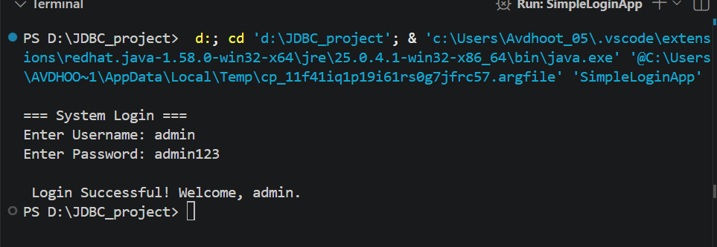

- Create a Java application using PreparedStatement to authenticate hospital staff login (doctor/nurse/login ID and password). Display appropriate access messages based on authentication result.

import javax.swing.*;
import java.awt.*;
import java.awt.event.ActionEvent;
import java.awt.event.ActionListener;
import java.sql.Connection;
import java.sql.DriverManager;
import java.sql.PreparedStatement;
import java.sql.ResultSet;

public class HospitalUI extends JFrame {
private static final String DB_URL = "jdbc:mysql://localhost:3306/hospital_db";
private static final String DB_USER = "root";
private static final String DB_PASSWORD = "Avdrocks@0504";

public HospitalUI() {
setTitle("Hospital Portal System");
setSize(450, 350);
setDefaultCloseOperation(JFrame.EXIT_ON_CLOSE);
setLocationRelativeTo(null);

JTabbedPane tabbedPane = new JTabbedPane();
tabbedPane.addTab("General Login", createGeneralLoginPanel());
tabbedPane.addTab("Staff Login", createStaffLoginPanel());

add(tabbedPane);
}

private JPanel createGeneralLoginPanel() {
JPanel panel = new JPanel(new GridBagLayout());
GridBagConstraints gbc = new GridBagConstraints();
gbc.insets = new Insets(8, 8, 8, 8);
gbc.fill = GridBagConstraints.HORIZONTAL;

JLabel lblTitle = new JLabel("=== System Login ===", SwingConstants.CENTER);
lblTitle.setFont(new Font("Arial", Font.BOLD, 16));

JLabel lblUser = new JLabel("Username:");
JTextField txtUser = new JTextField(15);
JLabel lblPass = new JLabel("Password:");
JPasswordField txtPass = new JPasswordField(15);
JButton btnLogin = new JButton("Login");
JLabel lblStatus = new JLabel("", SwingConstants.CENTER);

gbc.gridx = 0; gbc.gridy = 0; gbc.gridwidth = 2;
panel.add(lblTitle, gbc);

gbc.gridwidth = 1;
gbc.gridx = 0; gbc.gridy = 1;
panel.add(lblUser, gbc);
gbc.gridx = 1; gbc.gridy = 1;
panel.add(txtUser, gbc);

gbc.gridx = 0; gbc.gridy = 2;
panel.add(lblPass, gbc);
gbc.gridx = 1; gbc.gridy = 2;
panel.add(txtPass, gbc);

gbc.gridx = 0; gbc.gridy = 3; gbc.gridwidth = 2;
panel.add(btnLogin, gbc);

gbc.gridx = 0; gbc.gridy = 4; gbc.gridwidth = 2;
panel.add(lblStatus, gbc);

btnLogin.addActionListener(new ActionListener() {
@Override
public void actionPerformed(ActionEvent e) {
String username = txtUser.getText();
String password = new String(txtPass.getPassword());

String query = "SELECT * FROM users WHERE username = ? AND password = ?";
try (Connection conn = DriverManager.getConnection(DB_URL, DB_USER, DB_PASSWORD);
PreparedStatement pstmt = conn.prepareStatement(query)) {

pstmt.setString(1, username);
pstmt.setString(2, password);

try (ResultSet rs = pstmt.executeQuery()) {
if (rs.next()) {
lblStatus.setForeground(Color.GREEN.darker());
lblStatus.setText("Login Successful! Welcome, " + rs.getString("username") + ".");
} else {
lblStatus.setForeground(Color.RED);
lblStatus.setText("Invalid Username or Password.");
}
}
} catch (Exception ex) {
lblStatus.setForeground(Color.RED);
lblStatus.setText("Database Error: " + ex.getMessage());
}
}
});

return panel;
}

private JPanel createStaffLoginPanel() {
JPanel panel = new JPanel(new GridBagLayout());
GridBagConstraints gbc = new GridBagConstraints();
gbc.insets = new Insets(8, 8, 8, 8);
gbc.fill = GridBagConstraints.HORIZONTAL;

JLabel lblTitle = new JLabel("=== Hospital Staff Portal ===", SwingConstants.CENTER);
lblTitle.setFont(new Font("Arial", Font.BOLD, 16));

JLabel lblStaffId = new JLabel("Staff ID:");
JTextField txtStaffId = new JTextField(15);
JLabel lblPass = new JLabel("Password:");
JPasswordField txtPass = new JPasswordField(15);
JButton btnLogin = new JButton("Login");
JLabel lblStatus = new JLabel("", SwingConstants.CENTER);

gbc.gridx = 0; gbc.gridy = 0; gbc.gridwidth = 2;
panel.add(lblTitle, gbc);

gbc.gridwidth = 1;
gbc.gridx = 0; gbc.gridy = 1;
panel.add(lblStaffId, gbc);
gbc.gridx = 1; gbc.gridy = 1;
panel.add(txtStaffId, gbc);

gbc.gridx = 0; gbc.gridy = 2;
panel.add(lblPass, gbc);
gbc.gridx = 1; gbc.gridy = 2;
panel.add(txtPass, gbc);

gbc.gridx = 0; gbc.gridy = 3; gbc.gridwidth = 2;
panel.add(btnLogin, gbc);

gbc.gridx = 0; gbc.gridy = 4; gbc.gridwidth = 2;
panel.add(lblStatus, gbc);

btnLogin.addActionListener(new ActionListener() {
@Override
public void actionPerformed(ActionEvent e) {
String staffId = txtStaffId.getText();
String password = new String(txtPass.getPassword());

String query = "SELECT role FROM hospital_staff WHERE staff_id = ? AND password = ?";
try (Connection conn = DriverManager.getConnection(DB_URL, DB_USER, DB_PASSWORD);
PreparedStatement pstmt = conn.prepareStatement(query)) {

pstmt.setString(1, staffId);
pstmt.setString(2, password);

try (ResultSet rs = pstmt.executeQuery()) {
if (rs.next()) {
String role = rs.getString("role");
lblStatus.setForeground(Color.GREEN.darker());

if ("Doctor".equalsIgnoreCase(role)) {
lblStatus.setText("Access Granted: Welcome, Dr. " + staffId);
} else if ("Nurse".equalsIgnoreCase(role)) {
lblStatus.setText("Access Granted: Welcome, Nurse " + staffId);
} else {
lblStatus.setText("Access Granted: Welcome, Staff member.");
}
} else {
lblStatus.setForeground(Color.RED);
lblStatus.setText("Authentication Failed: Invalid Staff ID or Password.");
}
}
} catch (Exception ex) {
lblStatus.setForeground(Color.RED);
lblStatus.setText("Database Error: " + ex.getMessage());
}
}
});

return panel;
}

public static void main(String[] args) {
SwingUtilities.invokeLater(() -> {
new HospitalUI().setVisible(true);
});
}
}

OUTPUT:

